### User Story for Doctor Appointment booking

|  |  |
| --- | --- |
| **As a** | registered user of My appointment booking Application |
| **I want** | to book online appointment |
| **So that** | I can select a Date & Time slot as per my wish; moreover, I can pay the bill online with a 10% discount and a free checkup, or pay via cash with an additional cost, and also be able to rate doctors and view or download my final bill after the visit to the hospital. |
| **Acceptance Criteria** | 1. Registered User logs into the Jupiter application, and the system displays the **Home/Search** page 2. User then uses the filters with a newly added **Rating** filter to search for the doctors   (Refer: Appendix 2, Wireframe 1 & Appendix 3 – Data Table)   1. System displays the available result of doctors according to the users applied filter option to search   (Refer: Appendix 4, Wireframe 2 & Appendix 5 – Data Table)   1. User chooses the doctor from the available results and clicks on book an appointment command button of that selected doctor 2. System then navigates the user to the appointment booking page 3. User enters all the required details and also selects the date and time for the appointment   (Refer: Appendix 6, Wireframe 3 & Appendix 7 – Data Table)   1. User is asked to check the checkbox (100rs deposit for confirmation of the appointment) to proceed further with payment page 2. Once the User checks the checkbox, system navigates the user to the payment page 3. User is then asked to select either of the payment options  * Online payment with 10% discount on the total bill with a free checkup * Payment via cash with 50rs additional charges after the visit to the hospital   (Refer: Appendix 8, Wireframe 4 & Appendix 9 – Data Table)   1. User then decides one of them and proceeds with the chosen payment method 2. User receives the confirmation of the appointment from the hospital after successful appointment booking 3. User also receives a message from the hospital asking for confirmation with Yes/No options:  * If the user clicks on the yes command button system confirms the appointment * If the user clicks on no button system auto cancels the appointment   (Refer: Appendix 10, Wireframe 5 & Appendix 11 – Data Table)  Is user doesn’t reply:   * The call centre of the hospital makes a call with the patient for confirmation: * If the user receives the call the appointment is said to be confirmed * If the user doesn’t answer the call, system auto cancel the appointment of that patient  1. User visits the hospital on the appointed date and time 2. Users who paid online gets the discount and free checkup and the ones who paid via cash have to pay the additional charges and no free checkup 3. User receives a message/notification on the app where user can:   Rate the doctor (1-5 stars)  After rating they receive an option to view or download their bill onto their mobile device.  (Refer: Appendix 12, Wireframe 6,7 & Appendix 13 – Data Table) |

**Appendix 1:** ‘Online Appointment Booking’ Process Flow

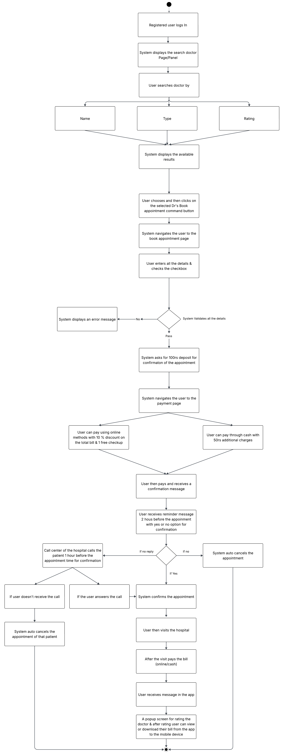

**Appendix 2:** Display ‘Rating’ Dropdown on ‘Home/Search’ Page, Wireframe 1

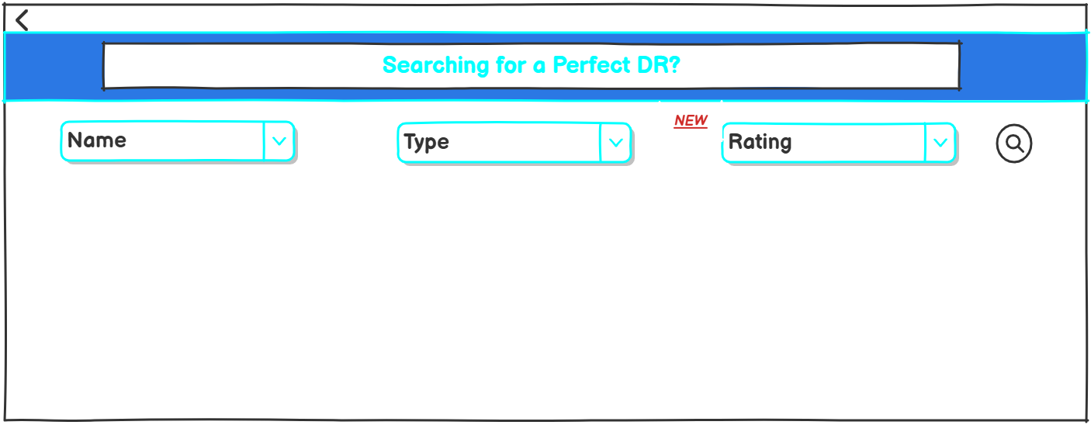

**Appendix 3:** Data Table for ‘Rating’ Dropdown

|  |  |  |  |  |  |  |  |
| --- | --- | --- | --- | --- | --- | --- | --- |
| **Sr. No.** | **Field Name** | **Field Type** | **Content** | **Required Field?** | **Min. Char.** | **Max Char.** | **Notes** |
| 1 | Rating | Dropdown | 1,1.5,2,2.5,3,3.5,4,4.5,5 | N/A | N/A | N/A | The dropdown should display different ratings, so that the user can filter and search for a doctor accordingly.  1 → Very Poor  2 → Poor  3 → Average  4 → Good  5 → Excellent |
| 2 | NEW | Label | N/A | N/A | N/A | N/A | The new tag/label describes that it is the new feature added to the application. |

**Appendix 4:** ‘Doctor list’ page, Wireframe 2

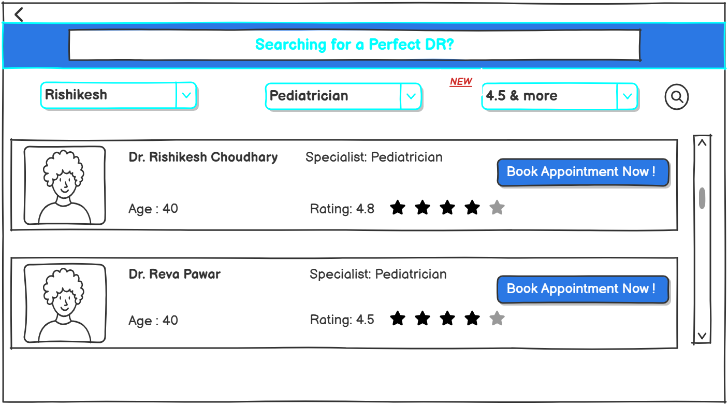

**Appendix 5:** ‘Doctor list’ Page Data Table

|  |  |  |  |  |  |  |  |
| --- | --- | --- | --- | --- | --- | --- | --- |
| **Sr. No.** | **Field Name** | **Field Type** | **Content** | **Required Field?** | **Min. Char.** | **Max Char.** | **Notes** |
| 1 | Doctor Name | Textbox | Dr. Rishikesh Choudhary  Dr. Reva Pawar | N/A | N/A | N/A | Display full name of the doctor |
| 2 | Doctor Photo | Image | N/A | N/A | N/A | N/A | Image of the doctor  Can be default avatar or uploaded image. |
| 3 | Age | Number | 40,50,60 | N/A | N/A | N/A | Displays the current age of the doctor |
| 4 | Specialist | Textbox | Pediatrician,general,etc | N/A | N/A | N/A | Displays the specialty field of the doctor |
| 5 | Rating | Number | 4, 4.5, 4.9, etc | N/A | N/A | N/A | The rating should include the average of the ratings given by the real patients also with stars for visual appeal. |
| 6 | Book Appointment Now | Command Button | N/A | N/A | N/A | N/A | On click, displays the Appointment booking page. |

**Appendix 6:** ‘Appointment Booking’ Page, Wireframe 3

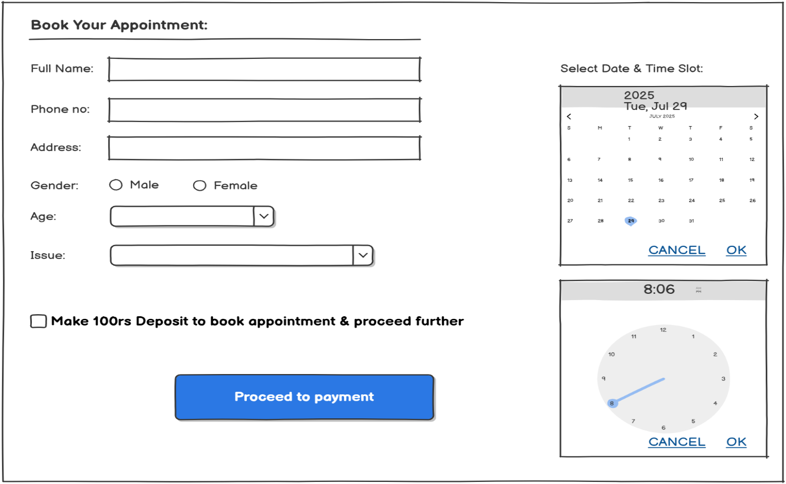

**Appendix 7:** ‘Appointment Booking’ Data Table

|  |  |  |  |  |  |  |  |
| --- | --- | --- | --- | --- | --- | --- | --- |
| **Sr. No.** | **Field Name** | **Field Type** | **Content** | **Required Field?** | **Min. Char.** | **Max Char.** | **Notes** |
| 1 | Full Name | Textbox | User's full name | Yes | 3 | 50 | Accept only alphabetic characters |
| 2 | Phone Number | Textbox | 10-digit mobile number(numeric) | Yes | 10 | 10 | 10 digit numeric format |
| 3 | Address | Multiline Textbox | Alphanumeric | Yes | 10 | 100 | Can be multiline |
| 4 | Gender | Radio Button | Male, Female | Yes | N/A | N/A | One option must be selected |
| 5 | Age | Dropdown | 1–100 | Yes | 1 | 3 | Only numeric options |
| 6 | Issue | Dropdown | (Fever, Diabetes, Chest Pain, etc.) | Yes | 3 | 50 | Populated from list of common medical issues |
| 7 | Date Picker | Calendar Widget | Select date (e.g., July 29, 2025) | Yes | N/A | N/A | Should not allow past dates  Should strike out the date which are not available for that particular patient |
| 8 | Time Slot | Clock Widget | Select time (e.g., 8:06 AM) | Yes | N/A | N/A | Show only available slots, no double booking |
| 9 | ₹100 Deposit Checkbox | Checkbox | "Make ₹100 deposit..." | Yes | N/A | N/A | Must be checked before enabling "Proceed to Payment" button |
| 10 | Proceed to Payment | Command Button | “Proceed to Payment” | Yes | N/A | N/A | On click, triggers the payment gateway |

**Appendix 8:** ‘Payment’ Page, Wireframe 4

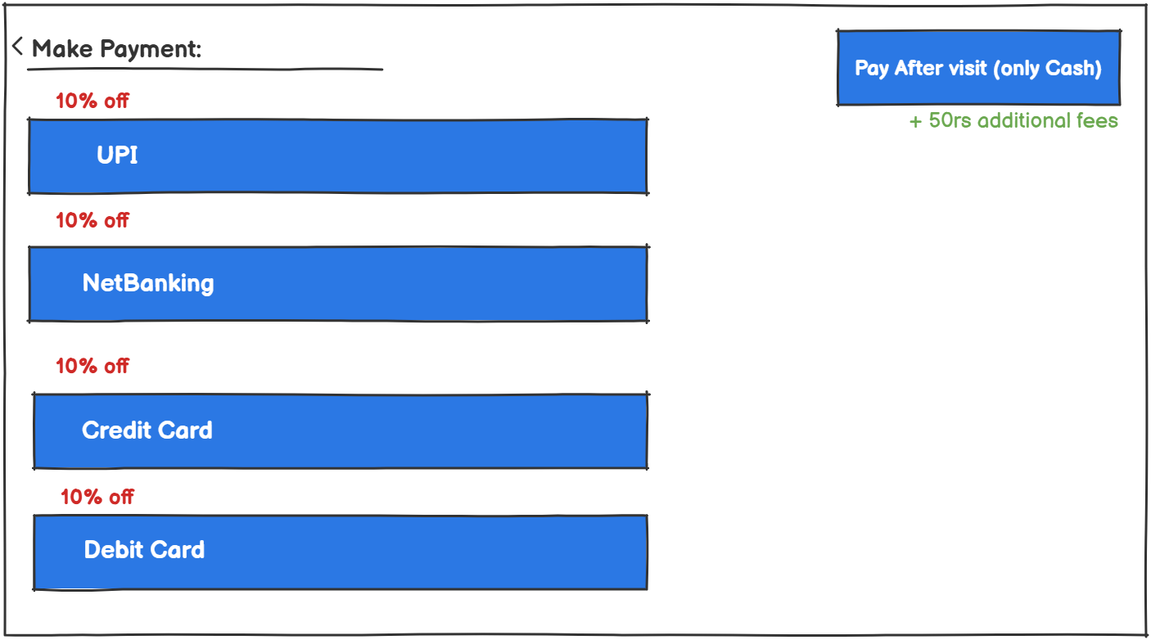

**Appendix 9:** ‘Payment’ Page Data Table

|  |  |  |  |  |  |  |  |
| --- | --- | --- | --- | --- | --- | --- | --- |
| Sr. No. | Field Name | Field Type | Content | Required Field? | Min. Char. | Max Char. | Notes |
| 1 | Discount Message | Label | "10% off" | No | N/A | N/A | Shown for online payment methods only. |
| 2 | Cash Payment Note | Label | "+50rs additional fees" | No | N/A | N/A | Displayed only if "Pay After Visit" (Cash) is selected.  Also on Cash payment charge 50rs extra. |

**Appendix 10:** ‘Confirmation’ Message, Wireframe 5

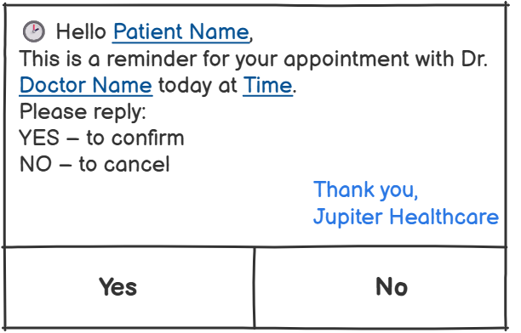

**Appendix 11:** ‘Confirmation’ Message Data Table

|  |  |  |  |  |  |  |  |
| --- | --- | --- | --- | --- | --- | --- | --- |
| **Sr. No.** | **Field Name** | **Field Type** | **Content** | **Required Field?** | **Min. Char.** | **Max Char.** | **Notes** |
| 1 | Patient Name | Dynamic Text | John Doe | Yes | 1 | 100 | Pulled from patient database based on appointment ID |
| 2 | Doctor Name | Dynamic Text | Dr. Rakesh Mehta | Yes | 1 | 100 | Pulled from doctor database linked to the appointment |
| 3 | Time | Dynamic Text | 10:30 AM | Yes | 5 | 10 | Appointment time to be inserted dynamically linked to the appointment |
| 4 | Reminder Message | Static Text | “This is a reminder…” | Yes | N/A | N/A | Fixed message text |
| 5 | Reply Options | Command Button | YES, NO | Yes | N/A | N/A | Clicking YES or NO sends response to backend |

**Appendix 12:** ‘Rate & Bill’ Page, Wireframe 6 & 7

Wireframe 6: Online Paid users will receive this!

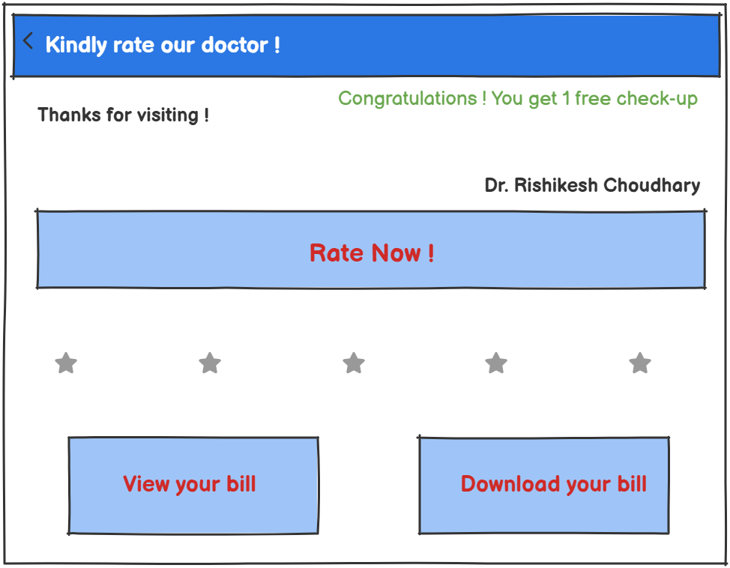

Wireframe 7: Offline/Cash paid users will receive this!

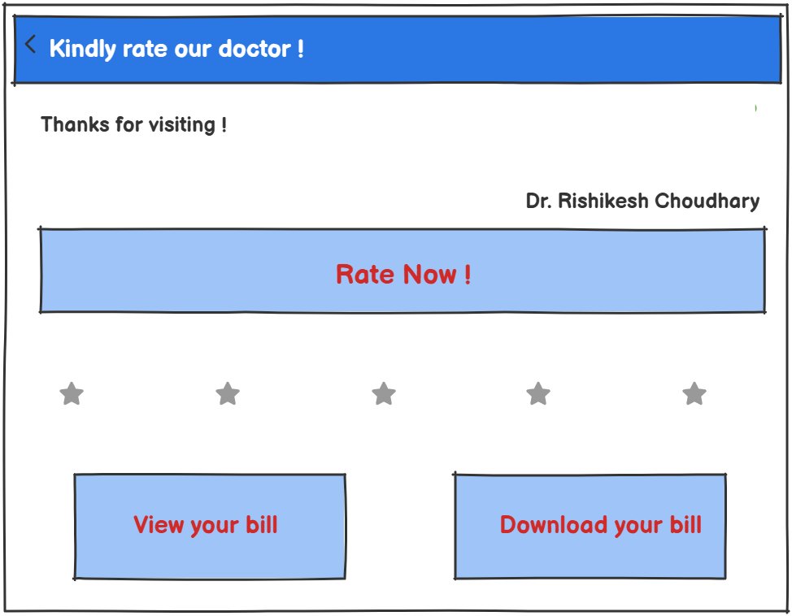

**Appendix 13:** ‘Rate & Bill’ Page Data table

|  |  |  |  |  |  |  |  |
| --- | --- | --- | --- | --- | --- | --- | --- |
| Sr. No. | Field Name | Field Type | Content | Required Field? | Min. Char. | Max Char. | Notes |
| 1 | Doctor Name | Text | Dr. Rishikesh Choudhary | Yes | 3 | 50 | Displayed automatically based on appointment. |
| 2 | Feedback Message | Label | "Thanks for visiting!" | No | 5 | 100 | Can be a dynamic or static message. |
| 3 | Rating Value | Star | 1 to 5 stars | Yes | N/A | N/A | Patient selects from 1–5 stars (mapped as numeric). |
| 4 | Free Check-up | Conditional Text | "You get 1 free check-up!" | No | N/A | N/A | Shown only if patient is eligible (after bill paid online). |
| 5 | Rate Now | Command button | "Rate Now!" | Yes | N/A | N/A | On click, submits the users rating |
| 6 | View Bill Button | Command Button | "View your bill" | Yes | N/A | N/A | Opens bill in-app |
| 7 | Download Bill Button | Command Button | "Download your bill" | Yes | N/A | N/A | Downloads bill as PDF to user’s device. |